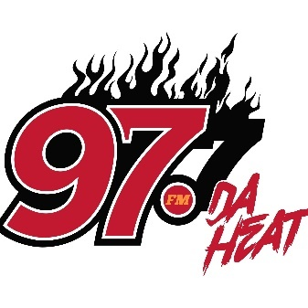
MUSIC SUBMISSION GUIDELINES
1. Submit (clean) radio versions of your music.
2. You must be the owner of the music or have the right to submit music for radio play.
3. All music must be submitted with album or track artwork.
4. All music must be in standard mp3 format and completely mastered before submission.
5. Submit all music to 977daheat@gmail.com
6.All submissions should contain social media and e-commerce information of the artist. i.e. (Facebook, Instagram, Twitter, iTunes, amazon, etc.)

